DIS-CAN-Eskimo-Ivory Cutter

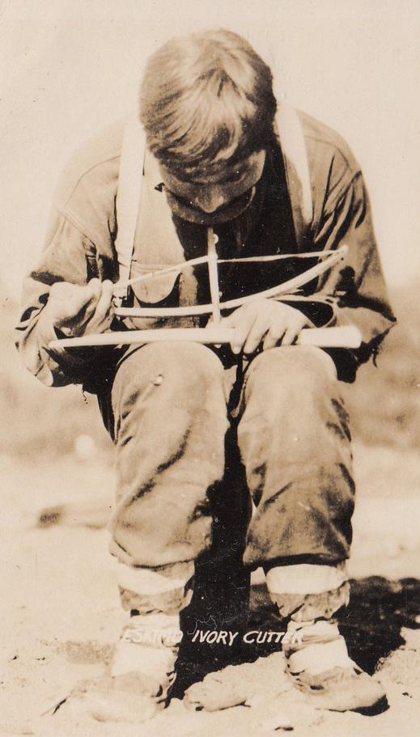

Postcard

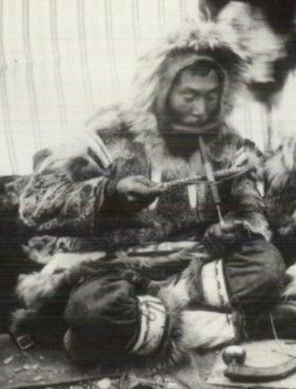

postcard 1930’s-1940’s

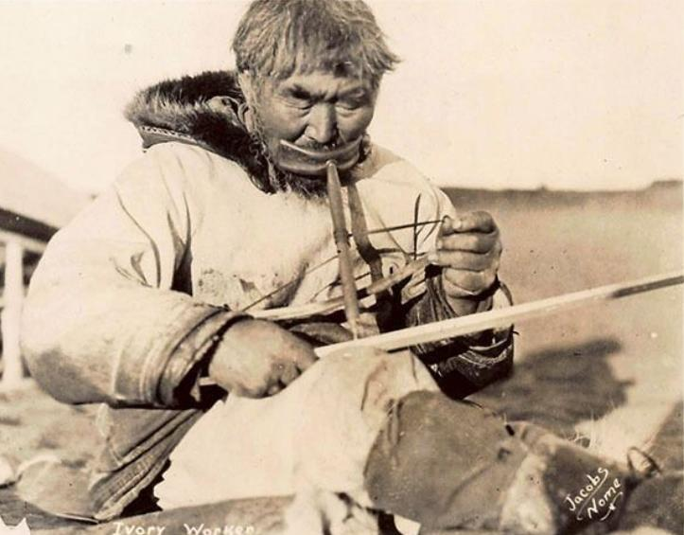

Nome AK Native Working w/ Ivory, Signed Jacobs, 1947

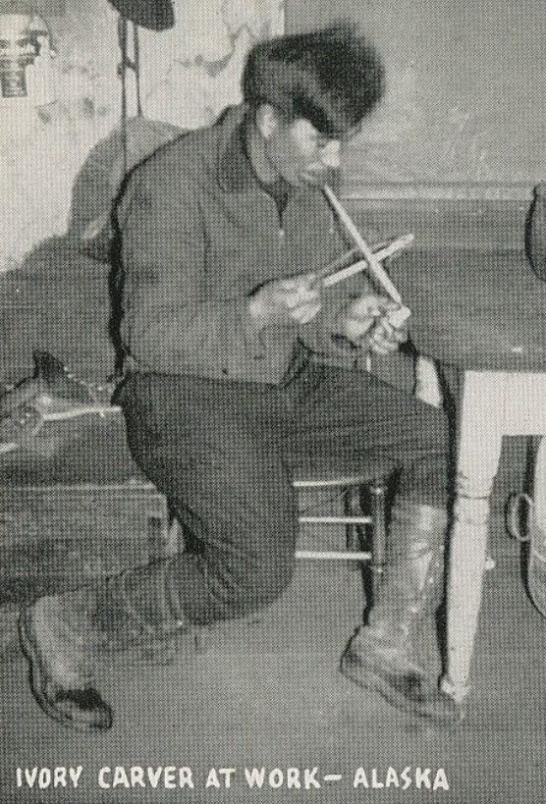

Northwest postcard Distributors